NAME THE EXPLORER!

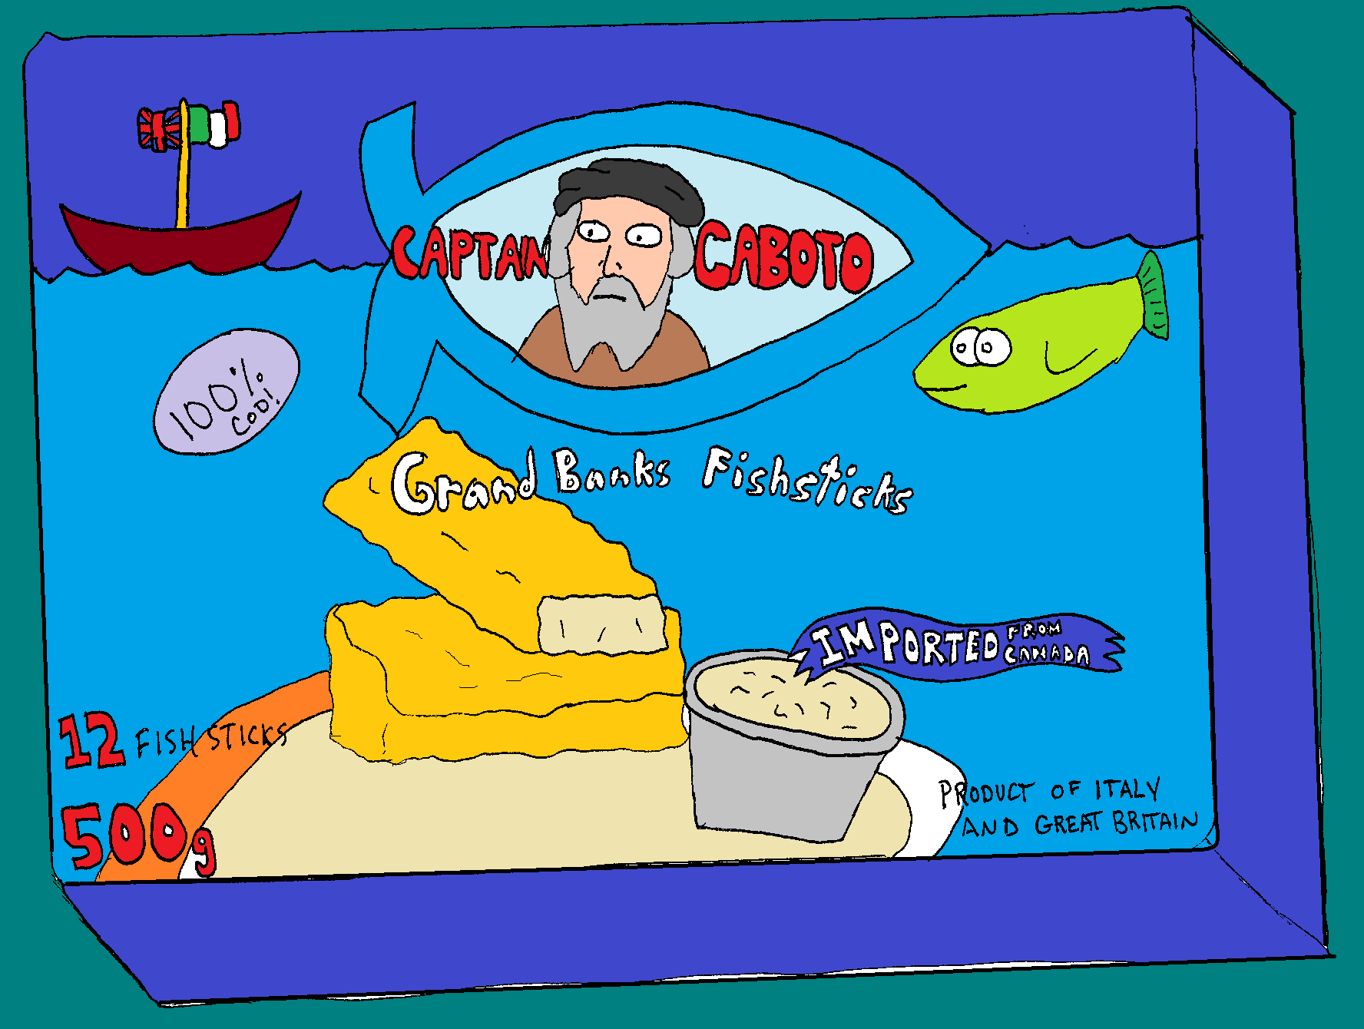

What are some important symbols/words in this cartoon?

Enter the search terms you inserted that helped you figure out who the explorer was

This Explorer is _________________

NAME THE EXPLORER!

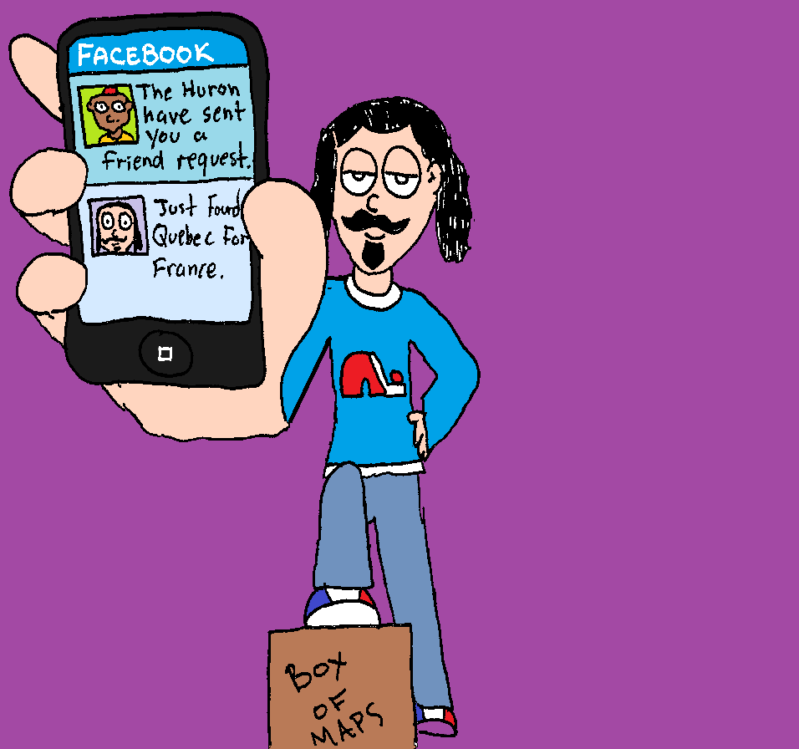

What are some important symbols/words in this cartoon?

Enter the search terms you inserted that helped you figure out who the explorer was

This Explorer is _________________
NAME THE EXPLORER!

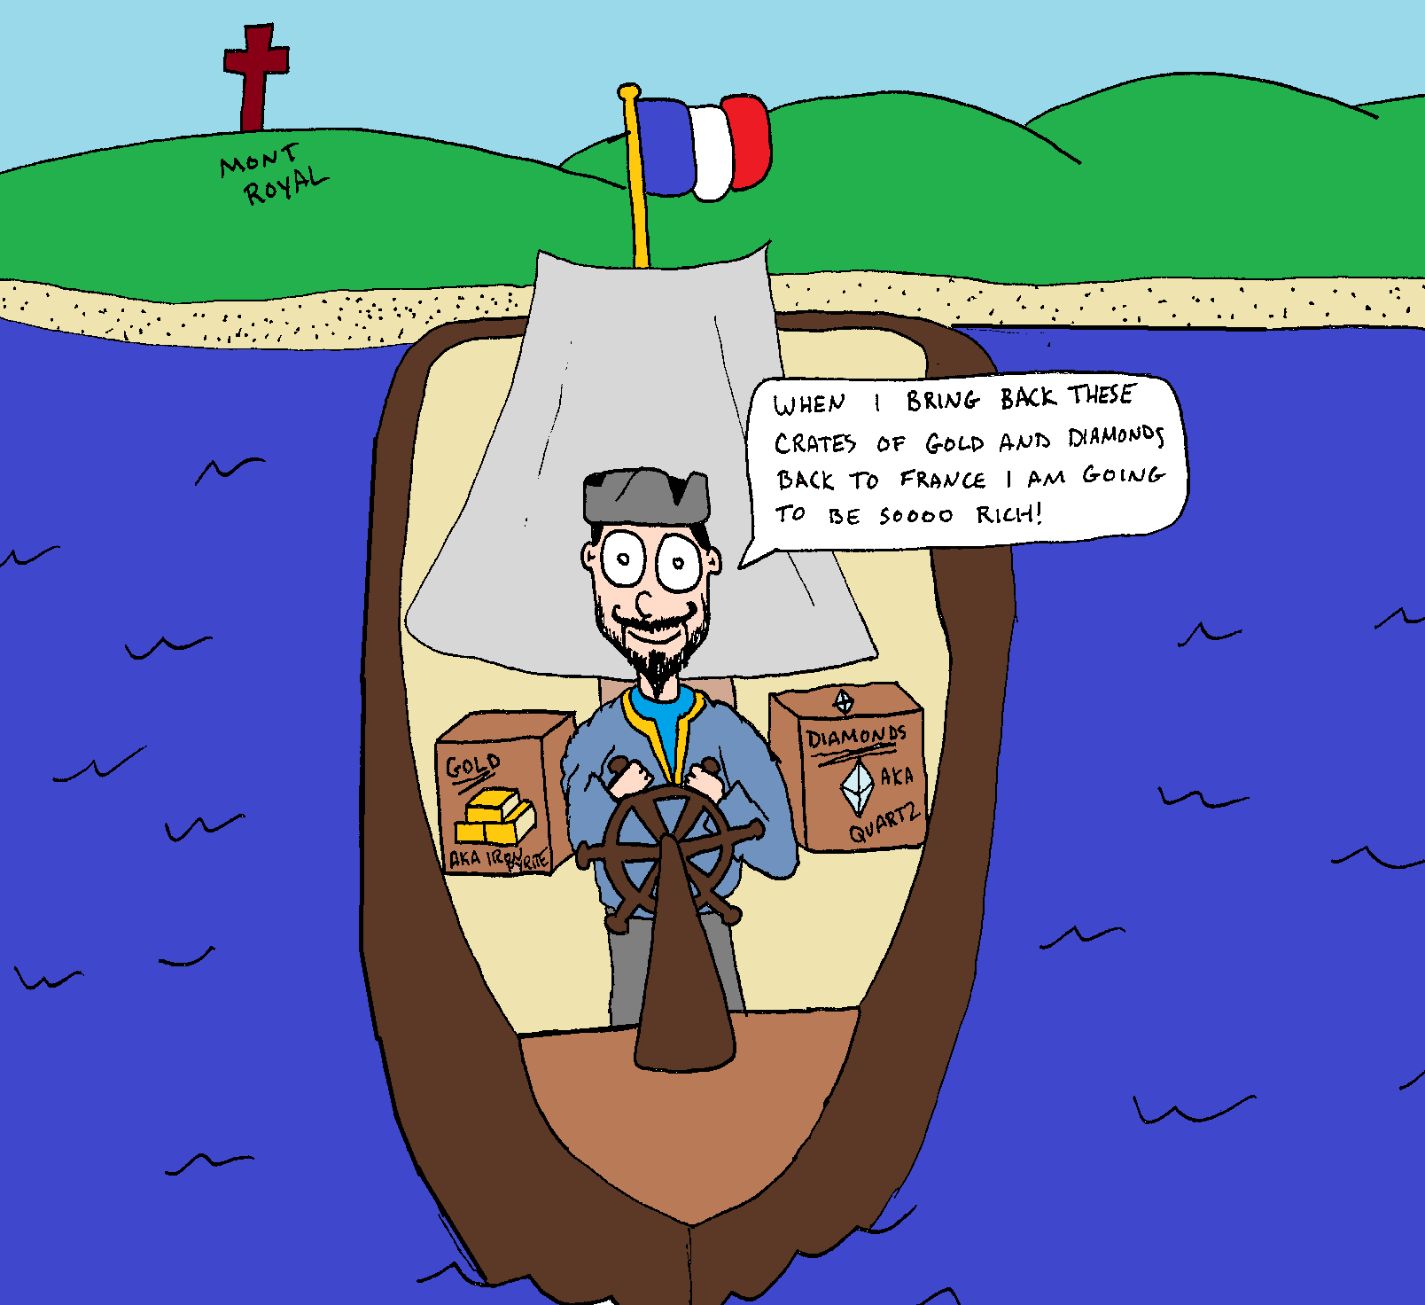

What are some important symbols/words in this cartoon?

Enter the search terms you inserted that helped you figure out who the explorer was

This Explorer is _________________
NAME THE EXPLORER!

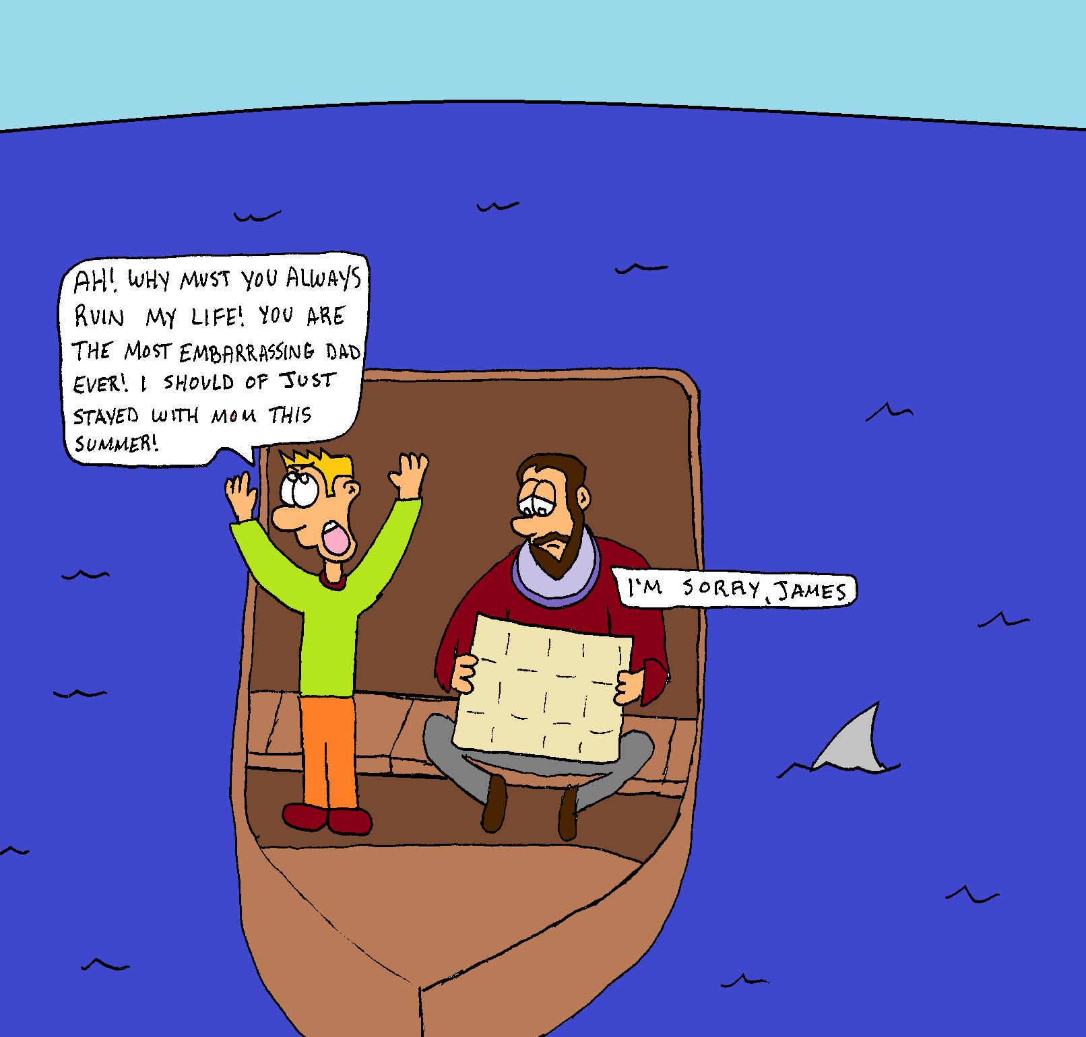

What are some important symbols/words in this cartoon?

Enter the search terms you inserted that helped you figure out who the explorer was

This Explorer is ________________

